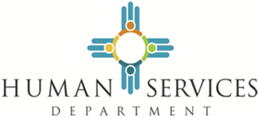
Food and Nutrition Services Bureau

Nicole Martinez- Program Manager
Nicole.Martinez2@hsd.nm.gov
505-841-2690

1425 William St. SE
Albuquerque NM 87102

Governor Michelle Lujan Grisham
David R. Scrase, M.D., Cabinet Secretary

Your completed request must be submitted by April 28, 2023 to receive USDA Foods in summer 2023
USDA Foods will be distributed in late May to early June 2023

Please Answer the Following:
- Are you approved to participate in the Summer Food Service Program through ECECD?
- Are you a school, government, or 501(c)(3)?
- Are you able to properly receive, store and utilize USDA Foods?
- Are working with a Food Service Management Company?
- Name of your Food Service Management Company? (If applicable)

Request to Receive USDA Foods- Summer Food Service Program

Agency Name:

Food Service Director:

Phone Number:
Email Address:

Physical Delivery Address:

